Large

* As a consumer, I want the system to be secure so that I don’t lose my money for unnecessary reasons. **2**
* As an employee of Colesworth, I want AfterPay to assume all credit and fraud risk so that there is a decreased risk for Colesworth. **6**
* As a consumer of Colesworth I want to be able to use the system at the cashiers, online, and for self service transactions so that I can use Afterpay at all points of transaction in the store. **13**

Medium

* As a customer, I want the system to be able to successfully complete my transactions both online and at Colesworth retailers so I can purchase my goods using card payment **1**
* As a non-technical consumer, I want the afterpay system to be easy to use and clear to understand so that I can save more time on paying. **3**
* As an employee of Colesworth, I want the system to be able to handle large amounts of concurrent transactions so that consumers don’t lose their money. **7**
* As a consumer, I want to be able to refund products so that if I am unsatisfied with the product I have bought, I can return the product and get my money back. **9**
* As an employee of Colesworth, I want the system to process transactions on average of 20 seconds so that there isn’t a backlog of consumers waiting to pay for their goods **10**
* As an administrator of AfterPay, I want to be able to access all employee’s level of access, so that I may amend any access when someone is promoted or resigned. **14**
* As an administrator of AfterPay, I want the authority of modifying the data, so that I can do system maintenance regularly. **15x**

Small

* As a consumer, I want to be able to pay back the money in fortnightly installments so that I can pay back the money in time. **4**
* As an administrator of AfterPay, I want to be able to view the system’s history and transactions, so that I may keep track of the revenue of the business. **5**
* As an employee of Colesworth, I want my password to be hidden so that unauthorized personals cannot view my password to login later on. **8**
* As an employee of Colesworth, I want the consumers to be able to pay using various cards so that we can have a wide variety of consumers. **11**
* As an administrator, I want to be able to shutdown the system, so that the system can avoid to take more risks after emergency situations. **12**

Dependency Graph

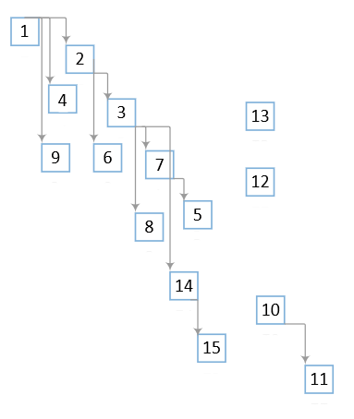

Release Plan

Stage 1 (2 months)

* **(1)** Complete transactions both online and in retailers
* **(4)** Allow customers to pay in fortnightly installments
* **(2)** Be a somewhat secure system
* **(9)** Allow customers to refund their goods at Colesworth
* Cut off date: 2 months after start of project

Stage 2 (2 months)

* **(3)** Allow the system to be easy to use for non technical customers
* **(6)** An even more secure system which now assumes that all credit and fraud risk
* **(8)** Allow employees to have hidden passwords
* **(7)** System can now handle very large amounts of concurrent transaction
* Cut off date: 2 months

Stage 3 (2 months)

* **(14)** Allow admins to have access to amending employee’s level access
* **(5)** Allow administrators to be able to view the systems history and transactions
* **(15)** Allow administrators to be able to modify data for maintenance
* **(11)** Allow consumers to pay with various cards
* **(10)** Process transactions in under 20s
* Cut Off Date: 2 months

Stage 4 - Finalizing stage

* System should now be 100% secure
* Resolve any crashes / bug fixes
* Get consumer and Colesworth feedback on the service
* Cut Off Date: 3 months